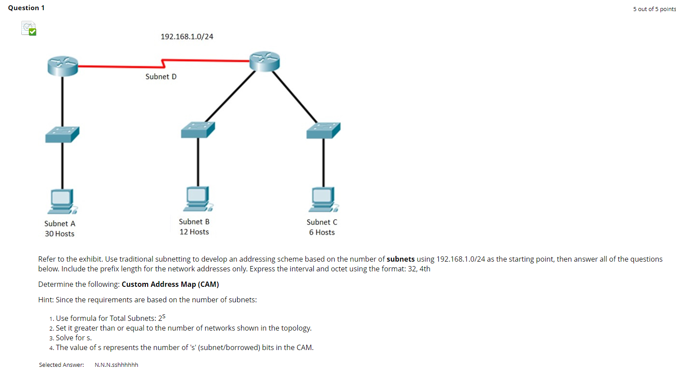
When there is 4 networks, ie subnet need to have 4
S represent borrowed bits
2 raise to s >= 4
2*S =2*2=4
S = 2
